Registration No. : 2025/CS/079
Index No. : 25000799
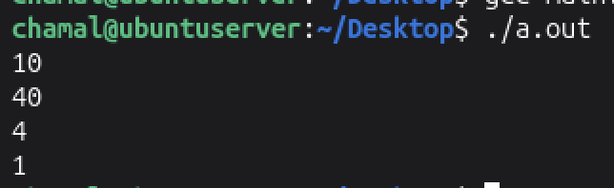
( 1 )
10
40
4
1

( 2 )
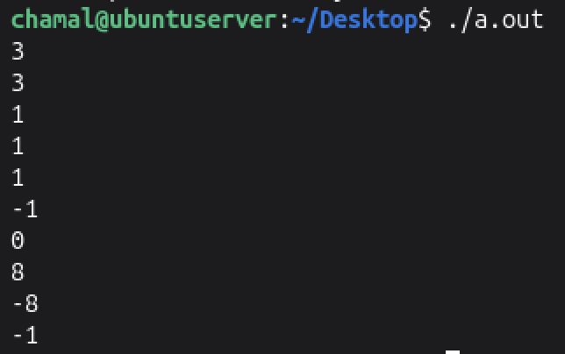
03 011
02 010
01 001
-01 111
Output:
3
3
1
1
1
-1
0
8
-8
-1

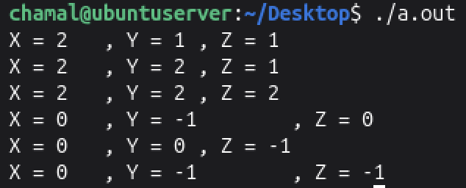
( 3 )
X = 2 , Y = 1 , Z = 1
X = 2 , Y = 2 , Z = 1
X = 2 , Y = 2 , Z = 2
X = 0 , Y = -1 , Z = 0
X = 0 , Y = 0 , Z = -1
X = 0 , Y = -1 , Z = -1

( 4 )
- FALSE It starts printing from where the cursor is
- TRUE All variables must be defined with a data type before using them
- FALSE All variables must have a data type
- FALSE % operator can be used with char as well.
- FALSE * and / has a higher precedence than + and -
- FALSE Some operators work right to left (Ex. Unary operators)
- FALSE You can use a single printf function associated with \n character
- TRUE Integer division is truncating the precision points after a division
- FALSE Variable names are case sensitive in C
- TRUE The function printf is declared inside the stdio.h header file.
( 5 )
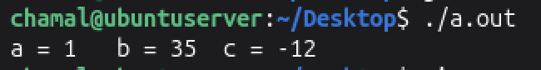
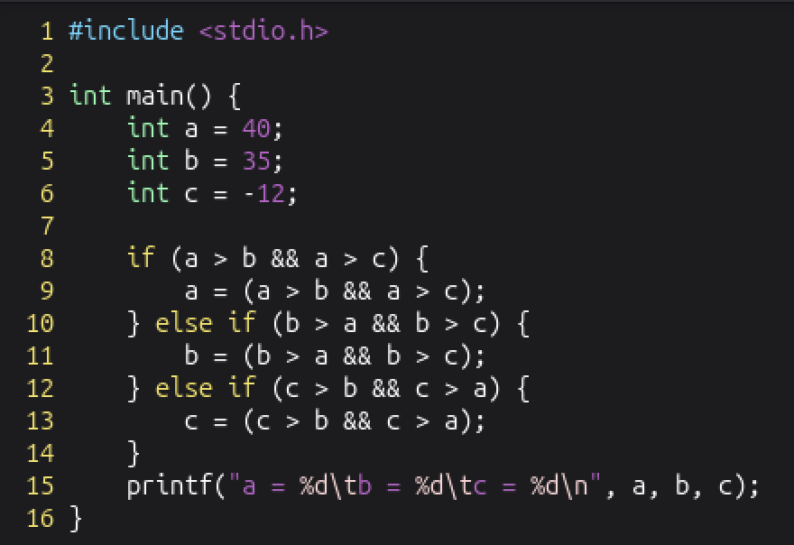

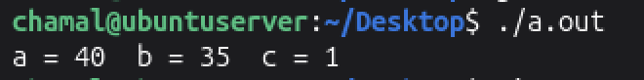
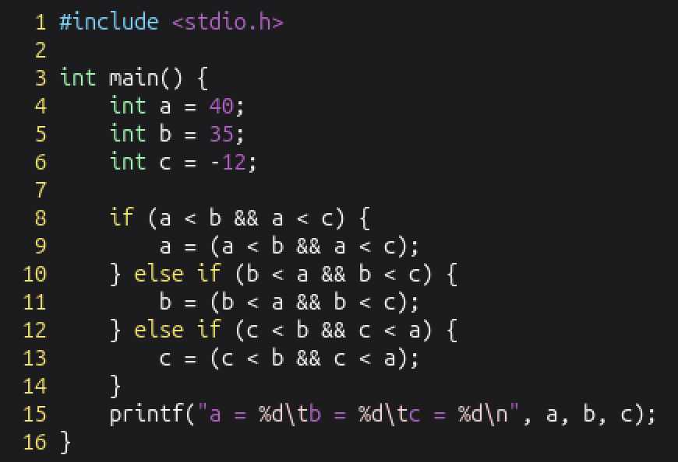

( 6 )
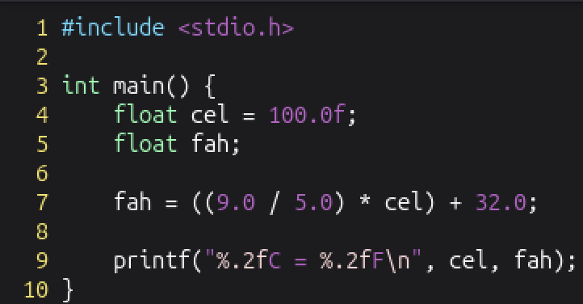
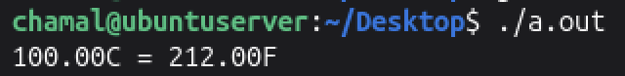

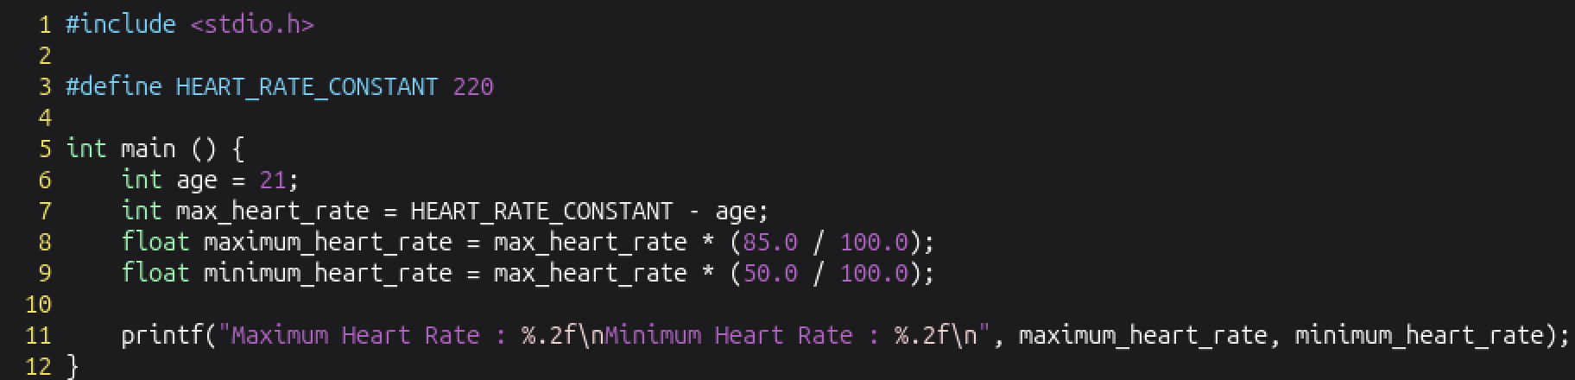

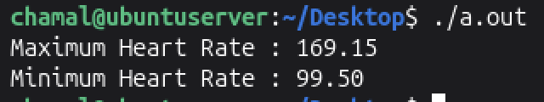

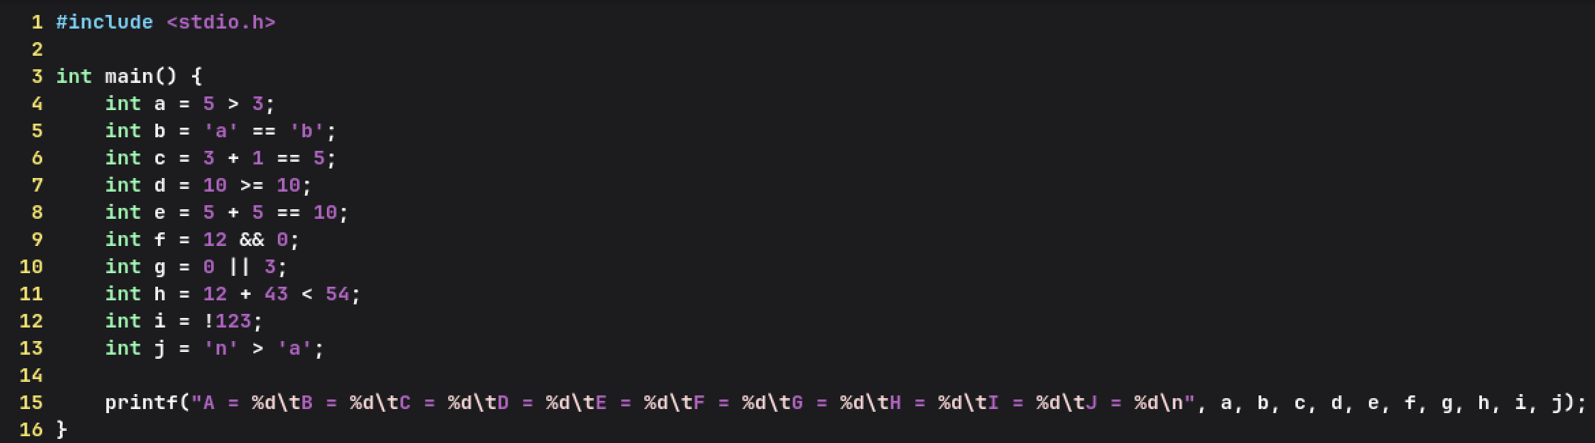

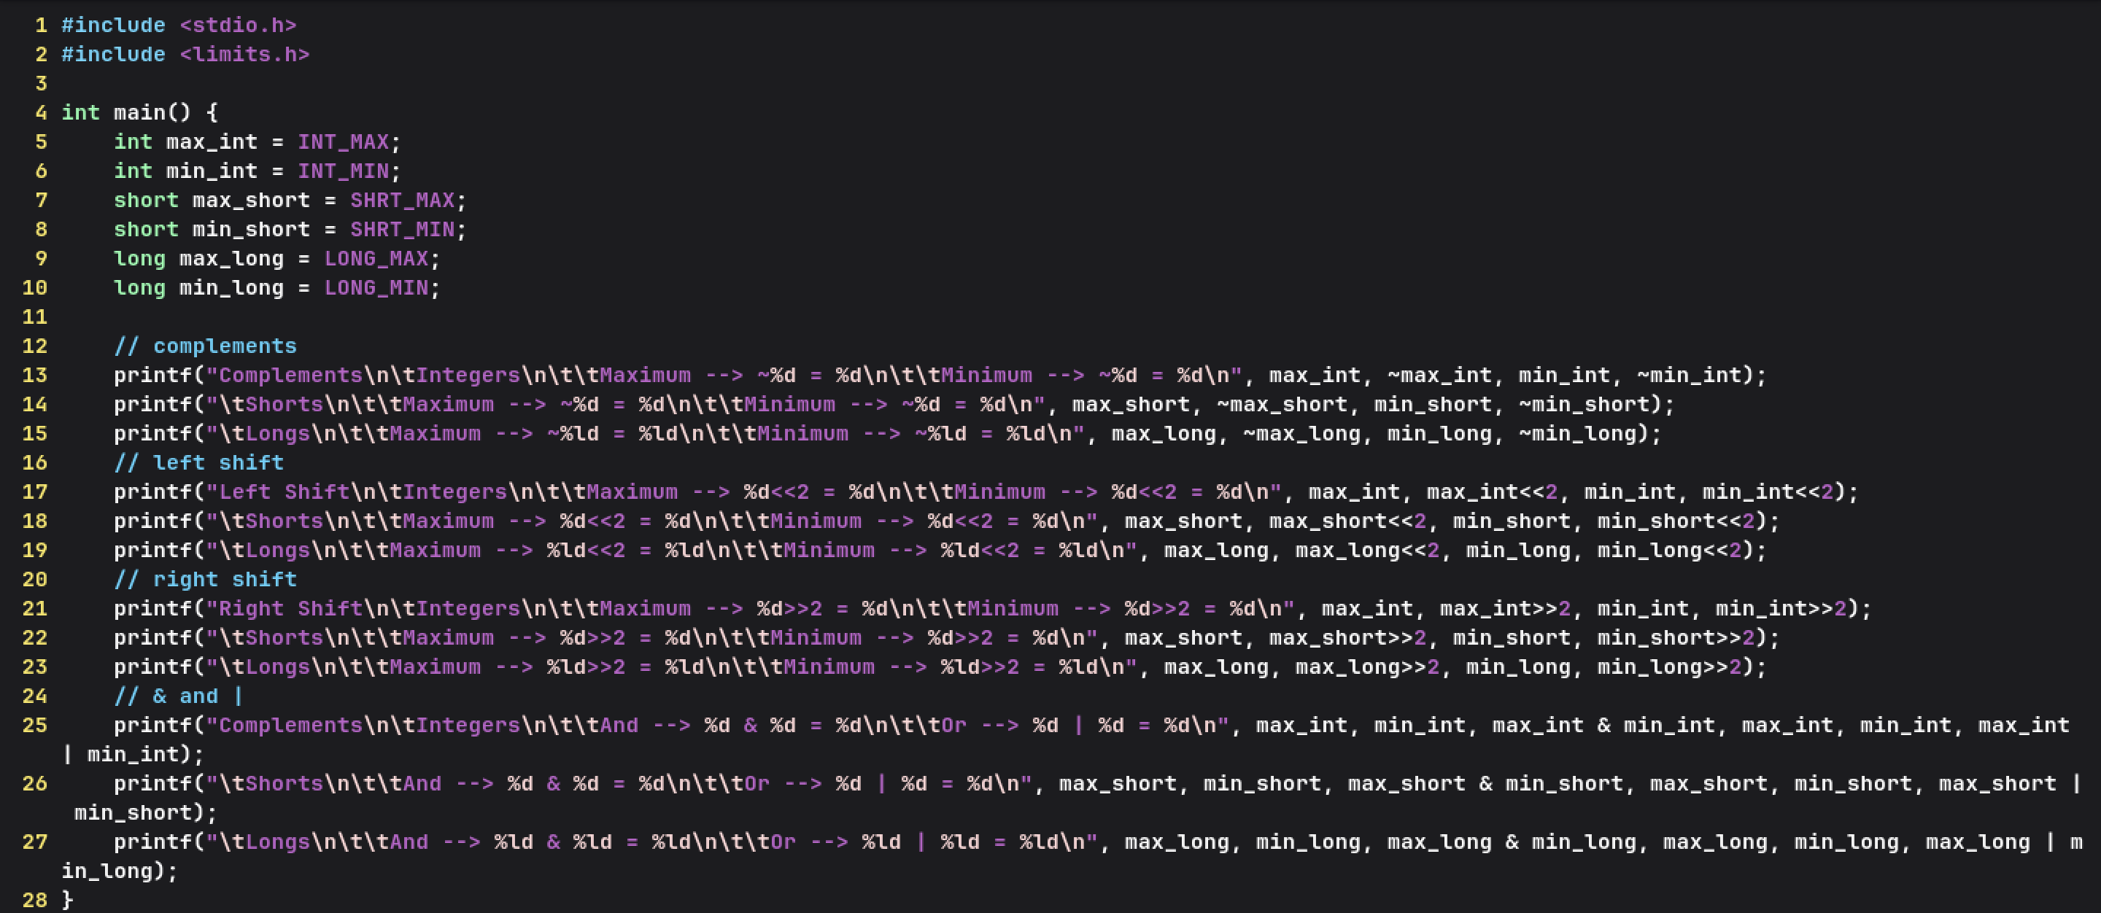

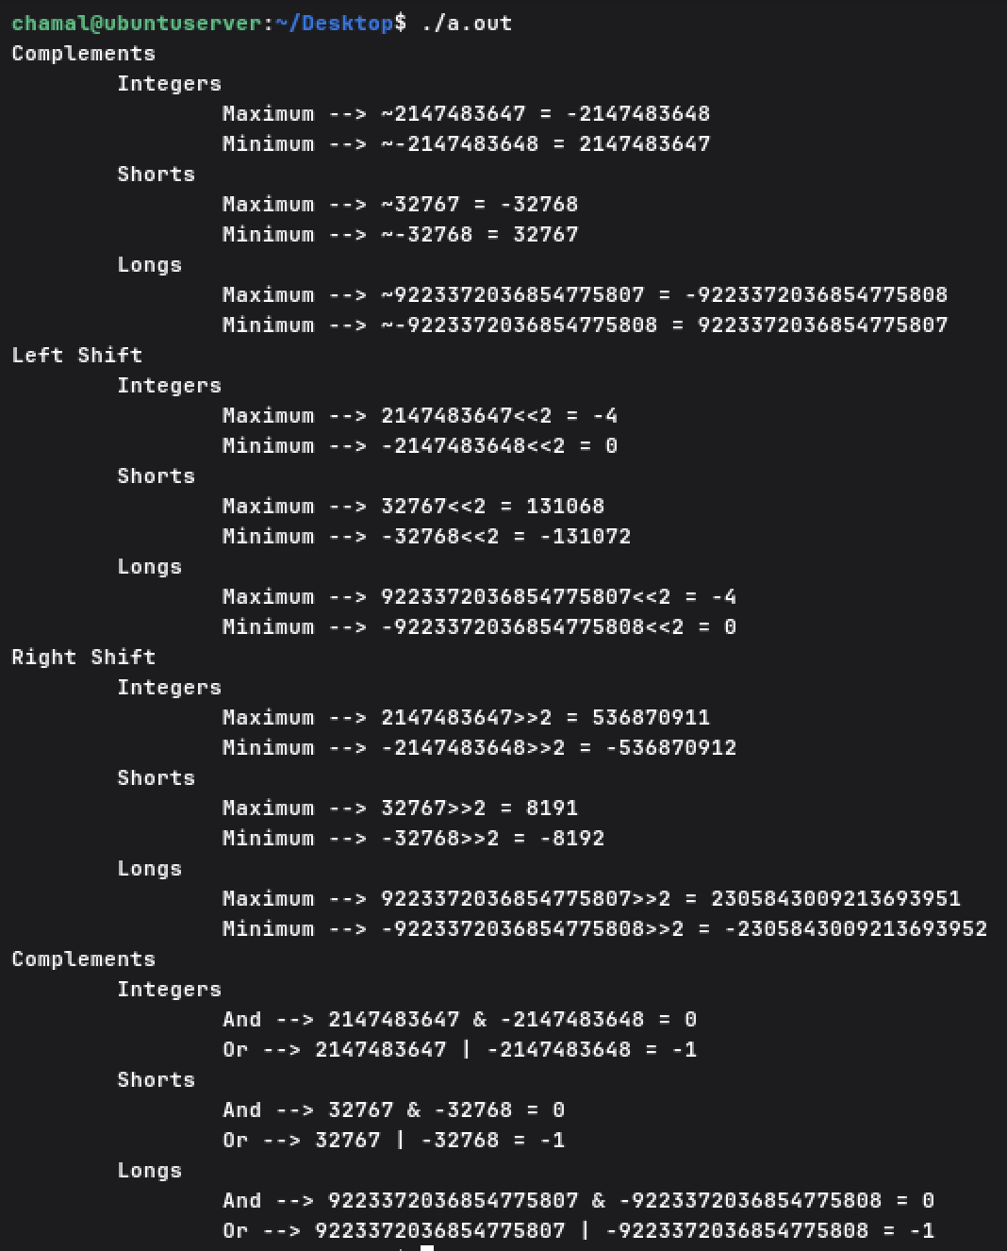

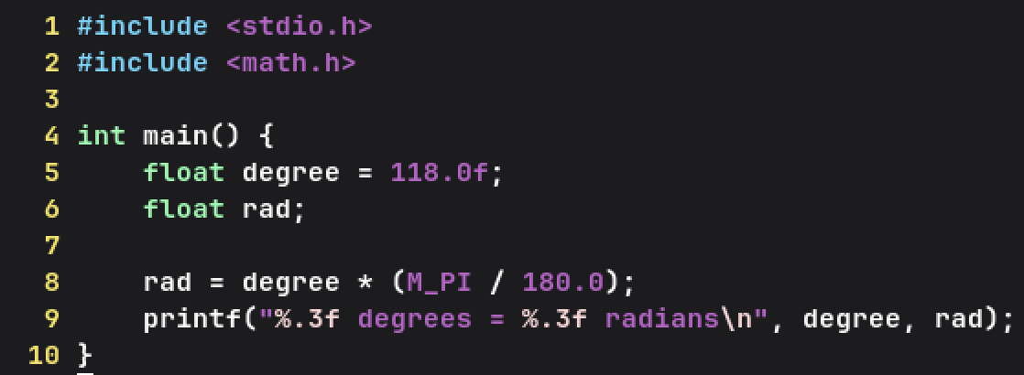
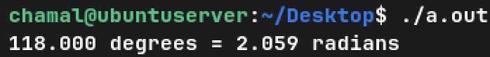

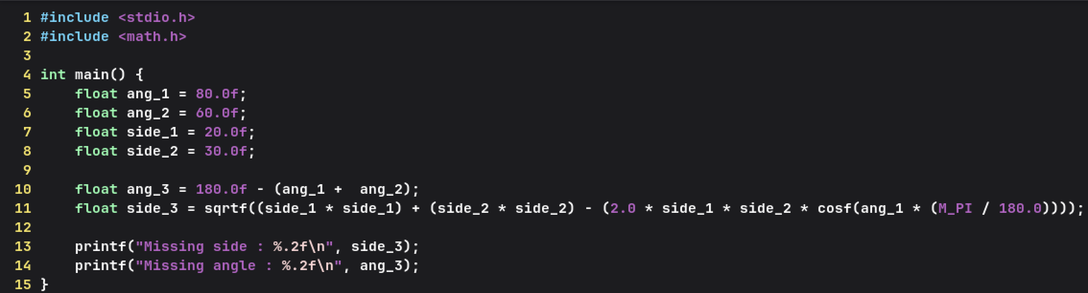

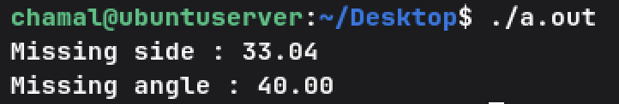

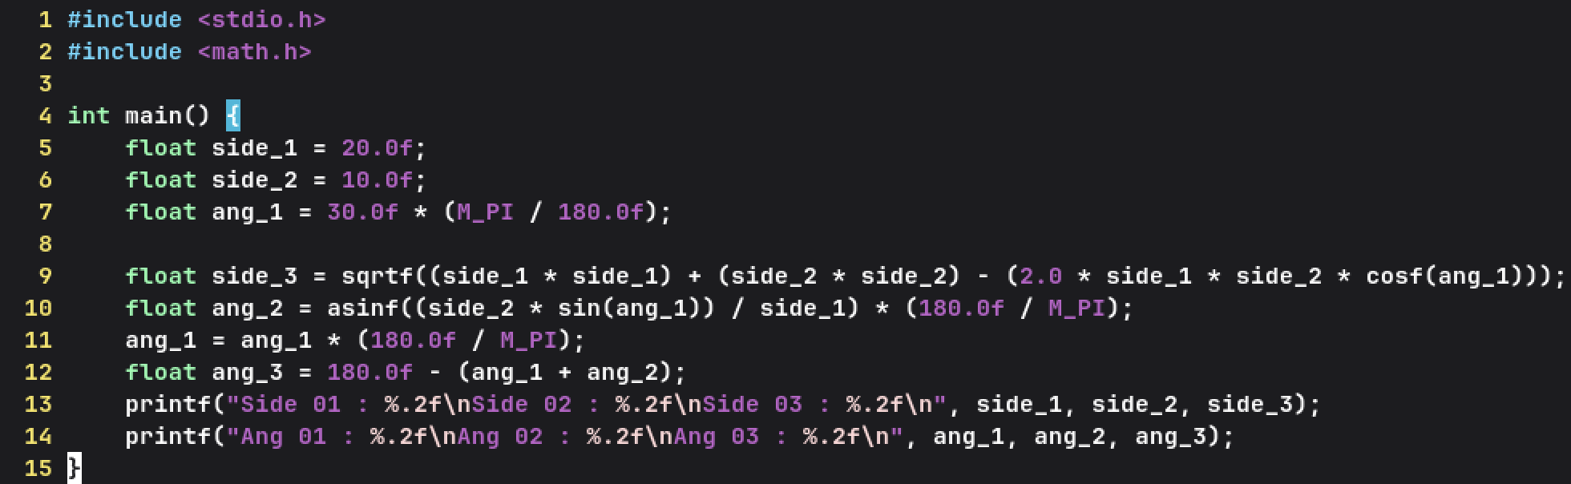

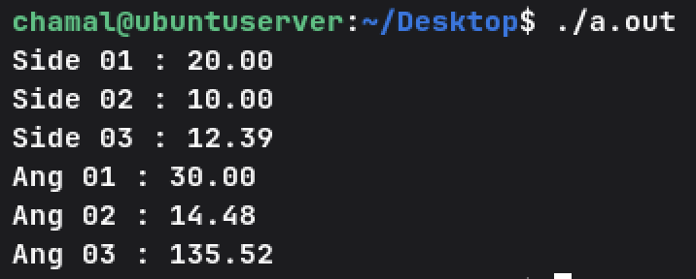

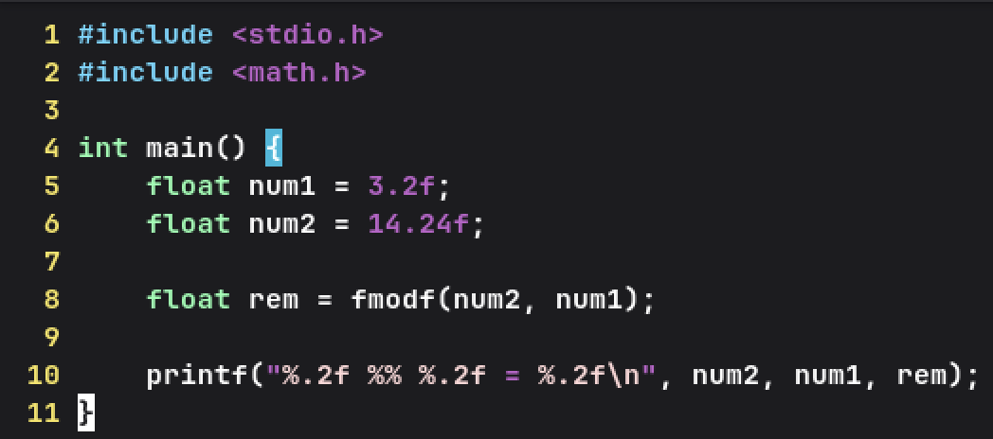
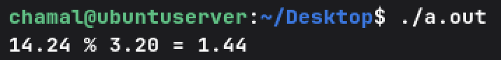

- clock_t is a fundamental arithmetic type that represents the processor time.

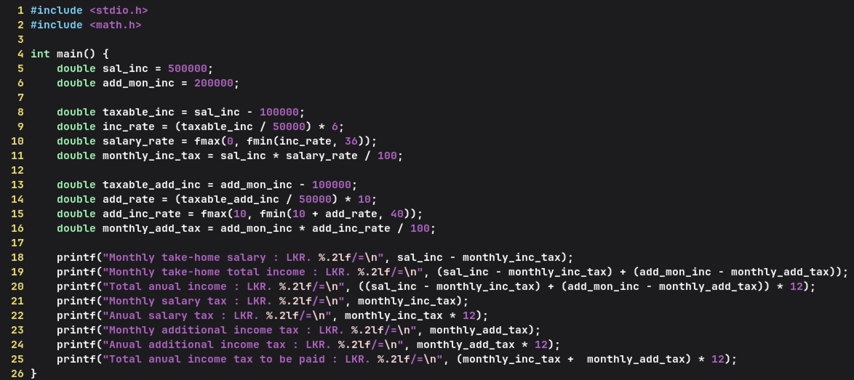
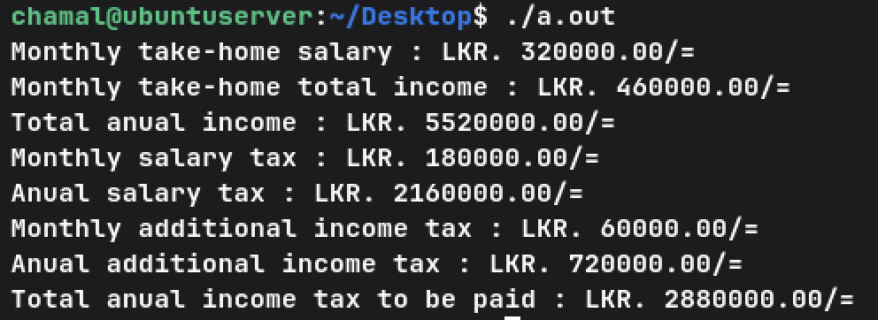

( 7 )
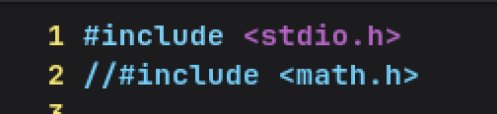
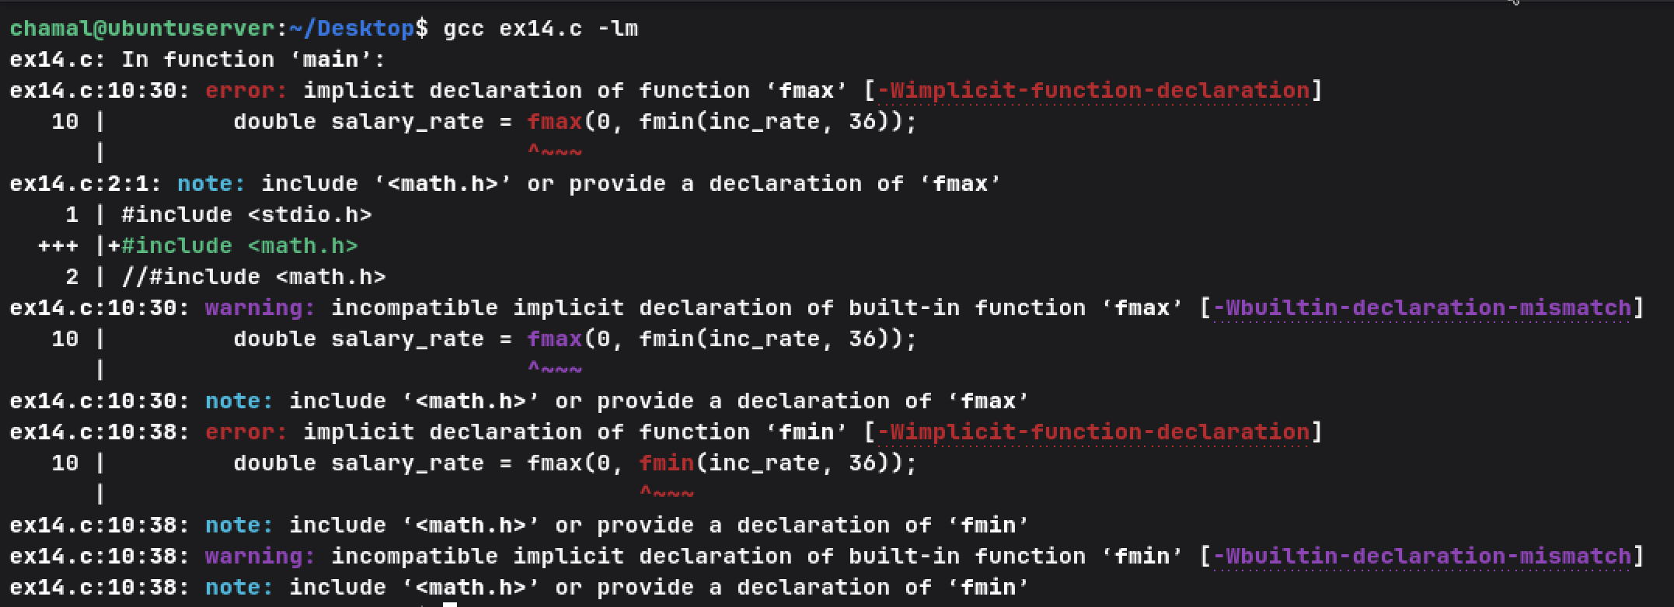

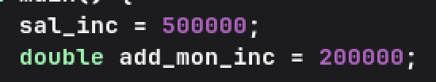
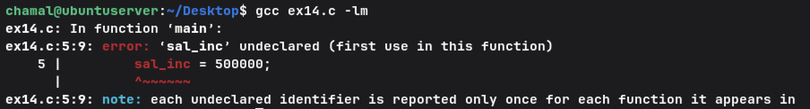
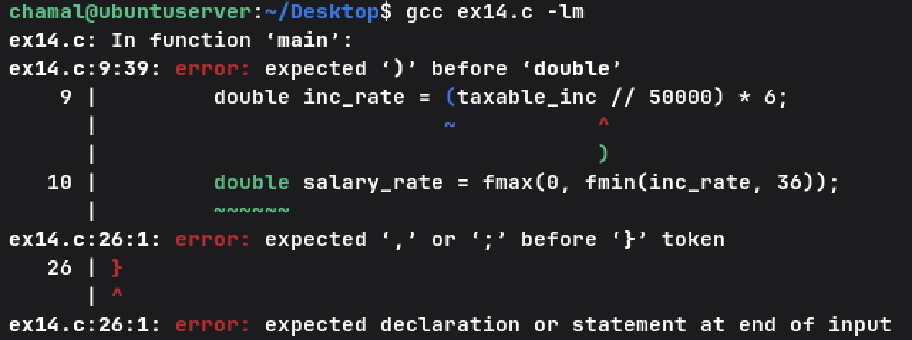
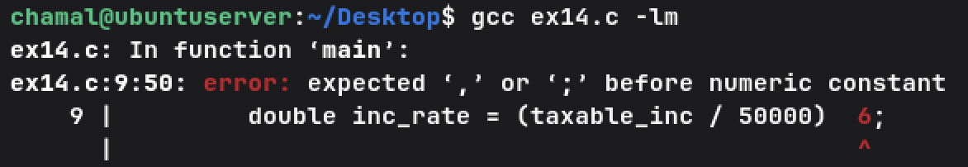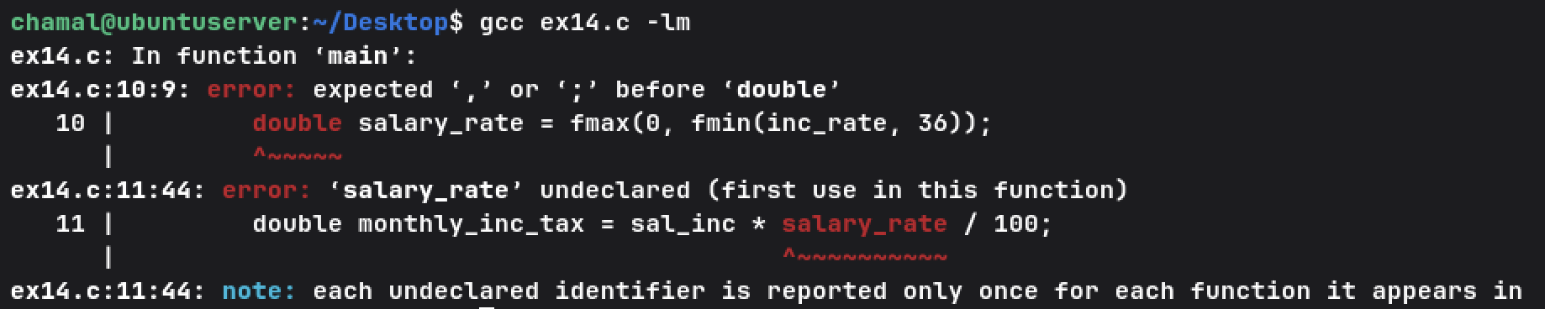
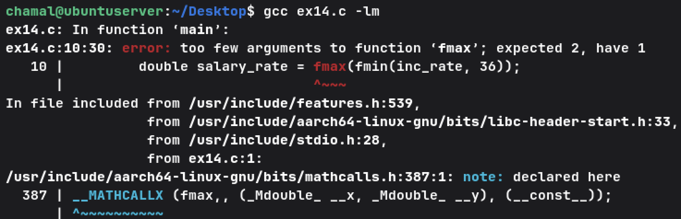
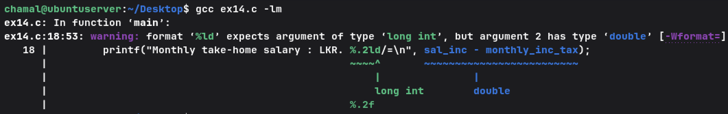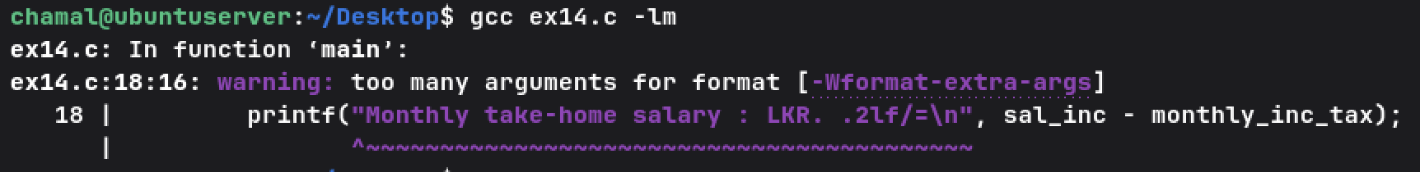

( 8 )
- puts() function is used to print strings on the screen. Unlike printf() function it automatically adds the new line character at the end of the string. Downsides of this are you can only print strings, and no formatting is available in puts() function. to use the function just pass a string as the parameter and the function will print it to the screen.

  - Both prints string to screen
  - Both are in the stdio.h header file

  - Euler's number
  - Pi
  - Golden ratio

